**INDIAN INSTITUTE OF INFORMATION TECHNOLOGY, DESIGN AND MANUFACTURING, KANCHEEPURAM**



**Course :** VLSI Design Practice

# AIM:

Implementation of Universal Up / Down counter using Verilog.

# introduction to digital counters:

Counter is a sequential circuit. A digital circuit which is used for a counting pulses is known counter. Counter is the widest application of flip-flops. It is a group of flip-flops with a clock signal applied.

Counting is frequently required in digital computers and other digital systems to record the number of events occurring in a specified interval of time. Normally an electronic counter is used for counting the number of pulses coming at the input line in a specified time period. The counter must possess memory since it has to remember its past states. As with other sequential logic circuits counters can be synchronous or asynchronous.

As the name suggests, it is a circuit which counts. The main purpose of the counter is to record the number of occurrences of some input.

# different types of counters:

There are many types of counter both binary and decimal. Commonly used counters are:

Binary Ripple Counter

Ring Counter

BCD Counter

Decade counter

Up down Counter

Frequency Counter

Binary Ripple Counter

Counters are of two types mainly:

* Asynchronous or ripple counters.
* Synchronous counters.

**4 – bit Synchronous Up Counter:**

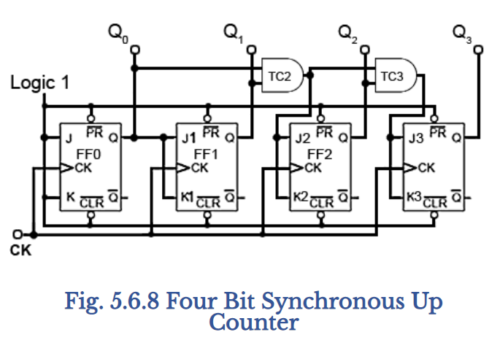

**4 – bit Synchronous Down Counter:**

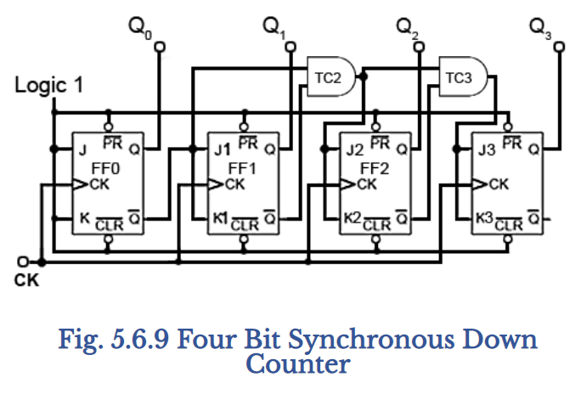

**4 – bit Synchronous Up / Down Counter:**

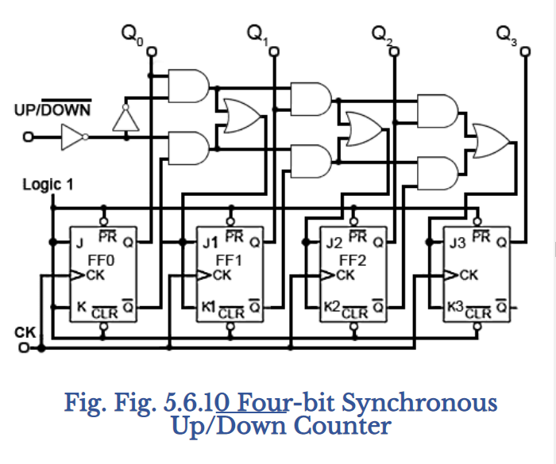

**4 – bit Asynchronous Up Counter:**

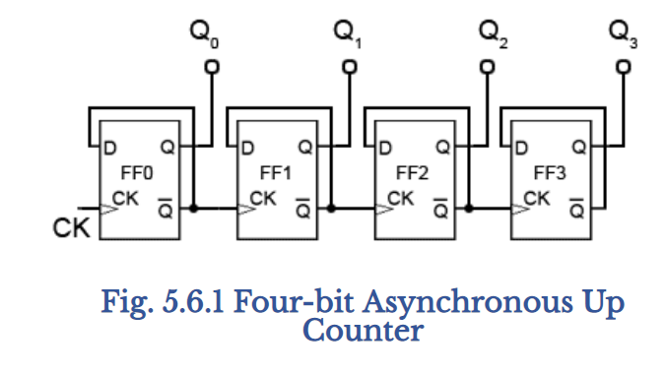

**4 – bit Asynchronous Down Counter:**

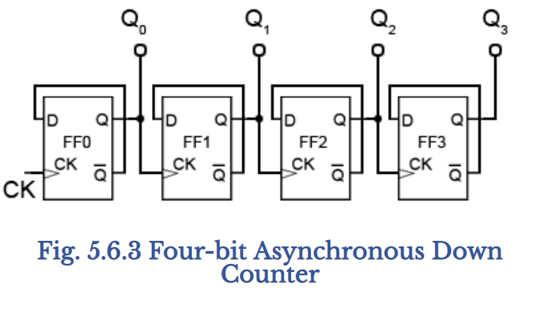

# references:

http://www.learnabout-electronics.org/Digital/dig56.php